

**Guidelines and Protocols for External Users** **Competitive Access to Gliders**

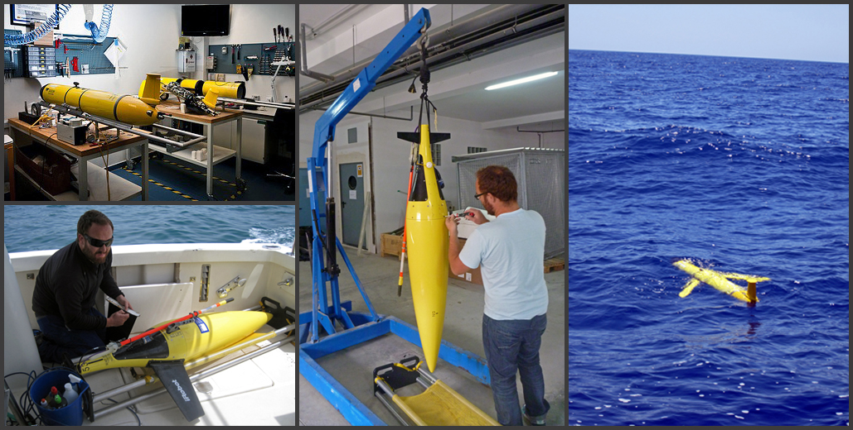

[**www.socib.es/competitive_access**](http://www.socib.es/~ksebastian/test_www/?seccion=gliderCompetitiveAccess)

**July 13, 2014**

**Contents**

1. Access Protocol and guidelines 3

1.1 General Overview 3

1.2 Eligibility 3

1.3 Type of Access and Specific Complementary Services 3

2. Access Costs 5

2. Calls 6

Description 6

4. Project Selection 7

4.1 Selection Criteria 7

4.2 Access Committee 7

4.3 Approval of Proposals 8

4.4 Post-access requirements 8

5. Annexes A 8

A. 5.1: Summary description of SOCIB glider Facility in March 2014: 8

# 1. Access Protocol and guidelines

## 1.1 General Overview

**SOCIB is offering access to its glider fleet** based in the Balearic Islands as described at [www.socib.es](http://www.socib.es/). This is a unique opportunity for scientists and engineers to use high-quality autonomous underwater infrastructures operating in coastal, shelf and open sea areas for carrying out research, monitoring and/or testing activities.

**SOCIB’s Glider Facility offers External Users Access** to ocean gliders, global leading edge platforms for international research and technology development, to complement its routine and strategic programme of glider endurance lines in the Mediterranean (up to 152 days in 2013). Since 2013, the available time for External Users Access is 90 days per year (96 effectively in 2013 due to a glider battery problem in the 1st deployment). For process-oriented studies (for example complementing a dedicated R/V cruise), a minimum of 7 days usage is required. Longer monitoring proposals of typically 30 days or more are encouraged.

This document presents the **External Users Access Protocol and Guidelines** and follows the EU Trans-National Access Programme (TNA) and other similar type of guidelines (e.g., the UPS 855 INSU/SDU “*Formulaire de demande de mise à disposition de gliders”* in France); specifically glider TNA access for external users was enabled through the [JERICO](http://www.jerico-fp7.eu/) EU funded project[1], successfully implemented during 2013.

**An external user group** can be a single researcher (user) or a team of two or more researchers (users). The external user will have to prepare a proposal in line with the template provided in Annex A.5.2. It is suggested that external user groups interact with the manager of the SOCIB Glider Facility during the preparation of proposals.

**Competitive access** to SOCIB Gliders is available through two dedicated project calls per year.

**The evaluation** of submitted proposals will be conducted on the basis of scientific excellence, enhancement of technology development and response to key societal challenges (e.g., MSFD implementation support activities).

**The Access granted to a specific experiment generally includes** support from SOCIB on: mission preparation and setup, training and logistical, technical, data management and scientific advice.

**Dedicated calls in emergent themes in the near future:** SOCIB will encourage the development of dedicated calls in emergent international themes where there is an opportunity for the overall achievement to be much greater than simply the sum of the individual proposals. Any such theme will follow an opportunity linked for example, to either a natural event (this could be an active under-sea volcano or a meteo-tsunami event etc.) or a community driver (acknowledging the timing of a consortium project -like JERICO or GROOM-). Dedicated calls will be clearly advertised.

## 1.2 Eligibility

Broad eligibility requirements ensure open research access and also access to commercial organisations; a user group must simply satisfy one of the following conditions.

a) The user group leader and the majority of the users work in an academic and/or ‘not-for-profit’ institution established in a Member State of the European Union or a State associated with the 7th Framework Programme and H2020. Costs will generally be met by the user group and/or the project grant holder unless SOCIB is explicitly funded as the glider provider in the original grant proposal.

b) The user group leader and the majority of the users work in an academic and/or ‘not-for-profit’ institution outside of the European Union. For example, SOCIB encourages applications from southern Mediterranean states enhancing capacity building as specifically included in H2020 and Blue Growth Actions under BG14[2]. Costs will be met by the user and/or the project grant holder in Euros.

c) The user group is a commercial organization, in which case direct contact with the Office of the Director is suggested.

## 1.3 Type of Access and Specific Complementary Services

Unless otherwise agreed, access to the Glider Facility by a user group is treated as a concession granted to use the infrastructure (one or several gliders, prior contact to SOCIB required to assure piloting and operation capabilities) in a dedicated experiment to collect specific data following the implementation of an automated measurement programme agreed between the user group and SOCIB.

A written contract or agreement between SOCIB and the user group will define the actions to be undertaken, the resources allocated, the period of planned user visits and/or training, the logistics of deployment and recovery, and the period of facility use, navigation piloting and data management. A template contract is provided in Annex A. 5.3. It will also define the rights and obligations of all the parties involved, including provisions for early termination of the conferred access or extensions if requested by a user group and mutually acceptable to SOCIB.

The requested access to SOCIB’s Glider Facility and their available infrastructure can follow three modes:

• **Remote**: the experiment is implemented by SOCIB and the presence of the user group is not required,

• **Partially remote**: the presence of the user group is required at some stage of the experiment.

• **"In person/hands-on"**: the presence of the user group is required during the whole access period of the experiment.

Unless otherwise stated, the measurement programme shall be provided by the user group. However, in all instances potential users are encouraged to consult with the SOCIB Glider Facility at any stage in proposal development. Careful scheduling and synchronising of events by SOCIB will minimise costs and maximise return from the overall glider programme.

**SOCIB will provide access to a number of specific complementary services**:

* Access to glider platforms prepared and ready for operation in line with the highest international standards.
* Qualified personnel for the management of the gliders (platforms and sensors), including logistics for deployment and recovery.
* A 24/7 operational system to pilot the gliders at sea.
* Access to a collaborative piloting system.
* Access to a collaborative Data Management system.
* Quasi Real Time (usually less than 6 hours) reception of data and visualization system
* State of the art quality control procedures (both for Real Time and Delayed Mode).
* A SOCIB standard post mission glider report.
* Delayed Mode data in NetCDF format.

**2. Access Costs**

Access costs are detailed in the enclosed table approved by the Executive Commission from SOCIB in 2013. For academic and “not-for-profit” organisations, the charge for glider operation in 2014 is € 1.538 per diem, subject to a minimum of 7 days usage (longer monitoring proposals of typically 30 days or more are encouraged). This charge is broken down in the enclosed table 1. This charge covers all costs associated with glider operations.

|  |  |  |  |
| --- | --- | --- | --- |
| **A. Description of the eligible costs in the lifespan of the gliders in SOCIB** | | | **Eligible costs (€)** |
| Costs of maintenance (sensors, consumables, etc.) | | | 225.000 |
| Travel and transportation for maintenance | | | 15.000 |
| Telecommunication costs | | | 135.000 |
| Sensor calibration | | | 60.000 |
| Insurance | | | 60.000 |
| Toxic treatment (batteries) | | | 2.000 |
| Data process costs | | | 66.840 |
| Personnel training | | | 34.128 |
| **Total A** | | | **597.968** |
| **B. Category of staff** | **Number of hours** | **Hourly rate** | **(3) =** |
| **(scientific and technical only)** | **(1)** | **(2)** | **(1) x (2)** |
| Head engineer | 4.500 | 40,89 | 184.005 |
| Electronic engineer | 3.600 | 40,89 | 147.204 |
| Computer engineer | 2.340 | 40,89 | 95.682,6 |
| Technician | 4.600 | 21,51 | 98.946 |
| Senior Scientist | 2.400 | 35,47 | 85.128 |
| Scientist | 2.400 | 35,47 | 85.128 |
|  |  |  |  |
|  |  |  |  |
|  |  |  |  |
| **Total B** | | | **696.094** |
| C. Indirect costs = 7% x (A+B) | | | 90.584,34 |
| D. Total estimated access eligible costs = A+B+C | | | 1.384.646,34 |
| E. Total estimated quantity of access provided to all normal users of the infrastructure  (i.e. both internal and external) within the project life-time (4 years) | | | 900 |
| F. Fraction of the Unit cost to be charged to the project | | | 100,0% |
| G. Estimated day cost = F x (D/E) | | | 1.538 |

Table 1. Cost for External Users Access

For commercial organisations (non-competitive access), contact the Office of the Director.

# 2. Calls

## Description

SOCIB’s Glider Facility has two annual calls. Please note that 1st calls are normally for projects starting in the first 6 months of the following year, and 2nd calls are for projects commencing in the second 6 months of the following year.

Under certain circumstances alternative timings may be requested, but it is strongly recommended that the proposed user group discuss this directly with the SOCIB Glider facility for proposal preparation, before project submission.

**The annual call programme is as follows.**

|  |  |  |
| --- | --- | --- |
| **1st January** | **1st call open** |  |
| **31st March** | **1st call submission deadline** |  |
| **15th July** | **Announce successful projects** | **2nd call open** |
| **30th September** |  | **2nd call submission deadline** |
| **1st January** | **1st call open** | **Announce successful projects** |

Proposals have to be drawn up in line with the proposal template (Annex 1) and sent by email by: 30th of September 2014 23:59 HOURS (CET), at the following email address: [GliderAccess_2_2014@socib.es](mailto:GliderAccess_2_2014@socib.es). The email address for proposal submission will no longer be accessible after this date.

**4. Project Selection**

## 4.1 Selection Criteria

Submitted proposals will be subjected to a two-step selection process by the Access Committee involving:

**I.** **Scientific excellence, technology development and innovation, and impacts on responding to key societal challenges.**

**II.** **Feasibility** of the proposal.

More specifically, the following criteria will be followed:

* Fundamental scientific or technical value
* Quality of the work program
* Evaluation of benefit and risk
* Relevance to understanding the characteristics and processes of variability in the Mediterranean Sea at different spatial and temporal scales.

Further details will be provided in each one of the public calls.

Consideration is given to all proposals; clearly those that have been subject to scientific peer review or which can easily demonstrate a novel hypothesis of societal, technological or scientific importance will be given priority.

## 4.2 Access Committee

The Access Committee comprises internationally well-recognised experts in new ocean observing platforms and glider operations. They will meet at least twice a year in the corresponding periods of proposal evaluation.

* Stefania Sparnocchia, CNR-IT
* Lukas Merckelback, HZG-GE
* Pierre Testor, CNRS/INSU-FR
* Carlos Barrera, PLOCAN-SP
* Marc Torner, SOCIB-SP

## 4.3 Approval of Proposals

The final ratings of the submitted proposals will be ranked in descending order. Approval for the specific experiment requested will be granted, starting with the proposal that has the highest rating and then working downwards.

The results of the selection will be posted on the SOCIB web site. The leader of each selected user group will be contacted directly by the manager of the Glider Facility to receive information/guidelines for in person/hands-on access or shipment for remote access.

## 4.4 Post-access requirements

After the end of the experiment, the user group leader must submit

**I.** A summary report to SOCIB describing the scientific output of the access received. Notification and details regarding the report format and submission deadline will be sent out via email in due time. The reports will be published on the SOCIB web site.

**II.** Any publications resulting from the experiment must be reported to SOCIB. Furthermore, all such publications must also contain references to the SOCIB agreement and acknowledgements to SOCIB. The involvement of SOCIB’s science interests, and SOCIB collaboration is encouraged at all stages.

**III.** SOCIB strongly encourages that data management follows the open access protocols of H2020 programme (http://ec.europa.eu/research/participants/data/ref/h2020/grants_manual/hi/oa_pilot/h2020-hi-oa-pilot-guide_en.pdf) and SOCIB Endurance lines with data being available through the SOCIB Data Centre web site.

**5. Annexes A**

## A. 5.1: Summary description of SOCIB glider Facility in March 2014:

Gliders are an example of new technologies being progressively implemented in coastal to open ocean regions allowing repeated high-resolution monitoring of specific areas, showing the dynamical relevance of new features, such as sub-mesoscale eddies that are characterised by strong horizontal gradients and intense vertical motions.

The Glider Facility is operational at SOCIB since 2013 and is run with in kind support (vehicle, laboratories and personnel) from IMEDEA (CSIC-UIB). SOCIB has improved the glider infrastructure providing new glider units, new electronics, pressure chamber (1.000 m), ballasting and operations labs, as well as new deployment capabilities (Hurricane Zodiac 9.2 m RIB; Van, etc.).

The present SOCIB glider fleet consists of 5 Slocum gliders (3 in kind from IMEDEA) and 2 iRobot Seagliders. More than 30 glider missions have been performed, collecting ~25000 hydrographic and biogeochemical profiles.

|  |  |  |  |  |  |  |  |  |
| --- | --- | --- | --- | --- | --- | --- | --- | --- |
|  | **Name** | **Model** | **Depth Range**  **(m)** | **Science Sensors** | **Max. Autonomy**  **(days)** | **Property Of** | **Managed**  **By** | **Purchase**  **Year** |
|  | **icoast00** | Slocum G1 | 0-200 | CTD, Oxygen, FLNTU | 24 | CSIC | SOCIB | 2007 |
| **ideep02** | Slocum G1 | 0-1000 | CTD, Oxygen, FLNTU | 24 | CSIC | SOCIB | 2009 |
| **ideep00** | Slocum G1 | 0-1000 | CTD, Oxygen, FLNTU | 24 | CSIC | SOCIB | 2010 |
| **sdeep00** | Slocum G2 | 0-1000 | CTD,  Oxygen, FLNTU | 60 | SOCIB | SOCIB | 2011 |
| **sdeep01** | Slocum G2 | 0-1000 | CTD, Oxygen, FLNTU | 60 | SOCIB | SOCIB | 2011 |
|  | **sdeep02** | Sea Glider | 0-1000 | CTD, Oxygen, FLNTU | 60 | SOCIB | SOCIB | 2012 |
| **sdeep03** | Sea Glider | 0-1000 | CTD, Oxygen, FLNTU | 60 | SOCIB | SOCIB | 2012 |

1. JERICO: Towards a Joint European Research Infrastructure network for Coastal Observatories
2. Tentative title: Supporting flagship international cooperation initiatives: Mediterranean and Black Sea Cooperation Research Alliance