

**Guidelines and Protocols for External Users Competitive Access to Gliders and R/V at SOCIB**

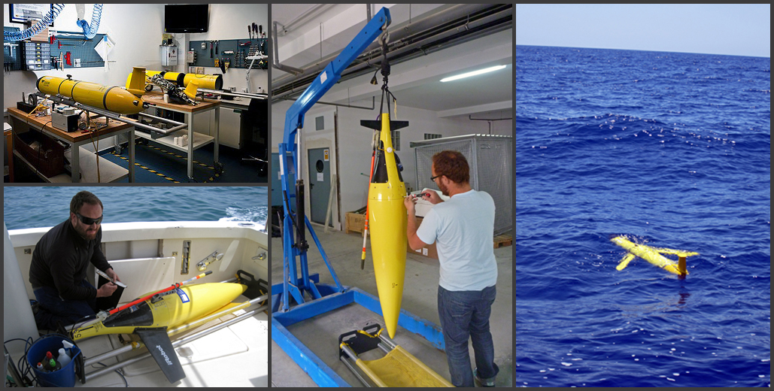

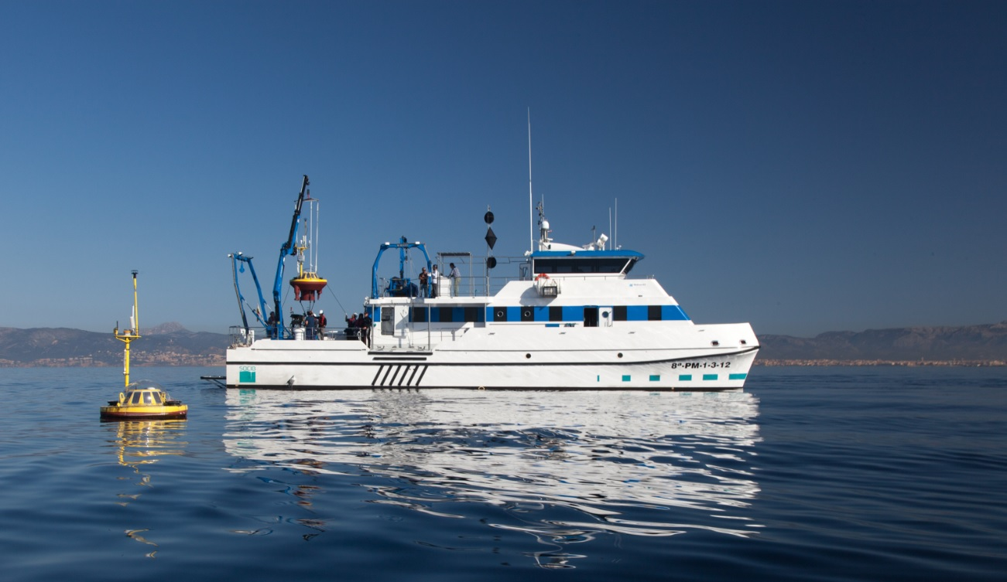

[**www.socib.es/competitive_access**](http://www.socib.es/~ksebastian/test_www/?seccion=gliderCompetitiveAccess)

**March 13, 2014**

**Contents**

Executive Summary 5

**A. Glider Facility Competitive Users Access Protocol and Guidelines** 7

1. Competitive Access Protocol 8

1.1 General Overview 8

1.2 Eligibility 9

1.3 Type of Access and Specific Complementary Services 9

2. Access Costs 10

3. Calls 11

3.1 Description 11

3.2 Dedicated calls in emergent themes 11

4. Project Selection 12

4.1 Selection Criteria 12

4.2 Access Committee 12

4.3 Approval of Proposals 13

4.4 Post-access requirements 13

5. Annexes A 14

A. 5.1: Summary description of SOCIB glider Facility in March 2014: 14

A. 5.2: Proposal Template for External Users Application to SOCIB Glider Facility 15

A. 5.3: Contract Template External User-Socib 21

A. 5.4: Cost for External Users Access 31

**B. R/V SOCIB Competitive Users Access Guidelines** 33

1. Competitive Users Access Guidelines 34

2. Annexes B 35

B. 2.1: SOCIB R/V daily costs for academic and private organisations 35

B. 2.2: SOCIB R/V proposal for ship time template. 37

# Executive Summary

This document presents the Guidelines and Protocols for competitive external users access to SOCIB Gliders and to R/V SOCIB. We also present the mission and composition of the Access Committee, the total Time Available for Competitive External Access –well above the 20% requested–, as well as the different Complementary Services that SOCIB provides to external users.

The information related to External Access was not sufficiently detailed in the initial version of the Strategic Plan 2013-2016 submitted June 30 2013[1], since, as we indicated in the Executive Summary, p. 7;

“*SOCIB in line with IP2010 is in* ***June 2013 operational*** *and has reached FOC (Final Operational Capability) of the different facilities and services. It is therefore an established and internationally recognised ocean observing and forecasting system, as described in detail in* ***Tintoré et al., (2013), see Annex 1****. Formally, as an ICTS, we are in a pre-operational phase, pending official recognition by the Large Scale Installations Spanish Board (CAIS), and this 2013-206 Strategic Plan is a key component for achieving this official status*.

In other words, we had reached FOC and different facilities were operational, but we had not yet received, the label for this from the CAIS. This was the case because the general evaluation procedure (that was formally initiated with an official letter dated February 27, 2013) was coincident with the start of operations of the different SOCIB facilities.

We are very thankful to the review committee to give us the opportunity to provide additional information included therefore in this document. More specifically, two types of facilities have been available and used during 2013 for competitive access to external users following international protocols and procedures in line with the Trans National Agreement procedures (from ESFRI, EU) for gliders and in line with procedures from the Spanish Research Fleet for the R/V SOCIB; in both cases, gliders and R/V SOCIB, with significantly more than 20% of time provided for external competitive access. We also provide here all the details requested on protocols, access committee, calls, procedures, etc.

It is also important to note that, as outlined in the 2013-2016 Strategic Plan under evaluation[2], SOCIB as a leading edge international marine infrastructure responds to a key paradigm change in ocean observation and data availability. A paradigm change by which not only Platforms are available for external users on a competitive basis, but also Data and Services are available to users (both scientists and society in general). This is the case at SOCIB, where facilities, data, products and services are available in quasi real time.

This approach from SOCIB is fully in line with international leading marine infrastructures in Canada (Neptune), Australia (IMOS), the US (OOI and IOOS) and also in Europe[3], where some of the major environmental infrastructures included in the ESFRI Road Map[4] (e.g., Euro-Argo, EMSO, ICOS or LIFEWATCH) are directly providing access to the data and services and not necessarily to the platforms (actually, some of the platforms being even of impossible access, such as for example the Argo profilers included in the Euro-Argo-ERIC being signed at present-, that drift at depths of the order of 1.000 m).

In summary, SOCIB provides competitive access to some of its platforms/infrastructures and also provides free and quality controlled access to data, products and services responding to science priorities, contributing to technology development and responding to society needs, fully in line with H2020.





# A. Glider Facility Competitive Users Access Protocol and Guidelines

# 1. Competitive Access Protocol

## 1.1 General Overview

**SOCIB is offering access to its glider fleet** (as described in Annex A. 5.1) based in the Balearic Islands as described at [www.socib.es](http://www.socib.es). This is a unique opportunity for scientists and engineers to use high-quality autonomous underwater infrastructures operating in coastal and shelf-sea areas for carrying out research, monitoring and/or testing activities.

**SOCIB’s Glider Facility offers External Users Access** to ocean gliders, global leading edge platforms for international research and technology development, to complement its routine and strategic programme of glider endurance lines in the Mediterranean (up to 152 days in 2013). Since 2013, the available time for External Users Access is 90 days per year (96 effectively in 2013 due to a glider battery problem in the 1st deployment). For process-oriented studies (for example complementing a dedicated R/V cruise), a minimum of 7 days usage is required. Longer monitoring proposals of typically 30 days or more are encouraged.

This document presents the **External Users Access Protocol and Guidelines** and follows the EU Trans-National Access Programme (TNA) and other similar type of guidelines (e.g., the UPS 855 INSU/SDU “*Formulaire de demande de mise à disposition de gliders”* in France); specifically glider TNA access for external users was enabled through the [JERICO](http://www.jerico-fp7.eu) EU funded project[5], successfully implemented during 2013.

**An external user group** can be a single researcher (user) or a team of two or more researchers (users). The external user will have to prepare a proposal in line with the template provided in Annex A.5.2. It is suggested that external user groups interact with the manager of the SOCIB Glider Facility during the preparation of proposals.

**Competitive access** to SOCIB Gliders is available through two dedicated project calls per year.

**The evaluation** of submitted proposals will be conducted on the basis of scientific excellence, enhancing technology development and responding to key societal challenges (e.g., MSFD implementation support activities).

**The Access granted to a specific experiment generally includes** support from SOCIB on: mission preparation and setup, training, and logistical, technical, data management and scientific advice.

## 1.2 Eligibility

Broad eligibility requirements ensure open research access and also access to commercial organisations; a user group must simply satisfy one of the following conditions.

a) The user group leader and the majority of the users work in an academic and/or ‘not-for-profit’ institution established in a Member State of the European Union or a State associated with the 7th Framework Programme and H2020. Costs will generally be met by the user group and/or the project grant holder unless SOCIB is explicitly funded as the glider provider in the original grant proposal.

b) The user group leader and the majority of the users work in an academic and/or ‘not-for-profit’ institution outside of the European Union. For example, SOCIB encourages applications from southern Mediterranean states enhancing capacity building as specifically included in H2020 and Blue Growth Actions under BG14[6]. Costs will be met by the user and/or the project grant holder in Euros.

c) The user group is a commercial organization, in which case direct contact with the Office of the Director is suggested.

## 1.3 Type of Access and Specific Complementary Services

Unless otherwise agreed, access to the Glider Facility by a user group is treated as a concession granted to use the infrastructure (one or several gliders) in a dedicated experiment to collect specific data following the implementation of an automated measurement programme agreed between the user group and SOCIB.

A written contract or agreement between SOCIB and the user group will define the actions to be undertaken, the resources allocated, the period of planned user visits and/or training, the logistics of deployment and recovery, and the period of facility use, navigation piloting and data management. A template contract is provided in Annex A. 5.3. It will also define the rights and obligations of all the parties involved, including provisions for early termination of the conferred access or extensions if requested by a user group and mutually acceptable to SOCIB.

The requested access to SOCIB’s Glider Facility and their available infrastructure can follow three modes:

• **Remote**: the experiment is implemented by SOCIB and the presence of the user group is not required,

• **Partially remote**: the presence of the user group is required at some stage of the experiment.

• **"In person/hands-on"**: the presence of the user group is required during the whole access period of the experiment.

Unless otherwise stated, the measurement programme shall be provided by the user group. However, in all instances potential users are encouraged to consult with the SOCIB Glider Facility at any stage in proposal development. Careful scheduling and synchronising of events by SOCIB will minimise costs and maximise return from the overall glider programme.

**SOCIB will provide access to a number of specific complementary services**:

* Access to glider platforms prepared and ready for operation in line with the highest international standards.
* Qualified personnel for the management of the gliders (platforms and sensors), including logistics for deployment and recovery.
* A 24/7 operational system to pilot the gliders at sea.
* Access to a collaborative piloting system.
* Access to a collaborative Data Management system.
* Quasi Real Time (usually less than 6 hours) reception of data and visualization system
* State of the art quality control procedures (both for Real Time and Delayed Mode).
* A SOCIB standard post mission glider report.
* Delayed Mode data in NetCDF format.

**2. Access Costs**

Access costs are detailed in the enclosed table approved by the Executive Commission from SOCIB in 2013. For academic and “not-for-profit” organisations, the charge for glider operation in 2014 is € 1,538 per diem, subject to a minimum of 7 days usage (longer monitoring proposals of typically 30 days or more are encouraged). This charge is broken down in the table in Annex A. 5.4. This charge covers all costs associated with glider operations.

For commercial organisations (non-competitive access), contact the Office of the Director.

**3. Calls**

## 3.1 Description

SOCIB’s Glider Facility will organize twocalls a year. Please note that 1st calls are normally for projects commencing in the first 6 months of the following year, and 2nd calls are for projects commencing in the second 6 months of the following year.

Under certain circumstances alternative timings may be requested, but it is strongly recommended that the proposed user group discuss this directly with the SOCIB Glider facility for proposal preparation, before project submission.

**The annual call programme is as follows.**

|  |  |  |
| --- | --- | --- |
| **1st January** | **1st call open** |  |
| **31st March** | **1st call submission deadline** |  |
| **1st July** | **Announce successful projects** | **2nd call open** |
| **30th September** |  | **2nd call submission deadline** |
| **1st January** | **1st call open** | **Announce successful projects** |

Due to the late start in 2014, the deadline for the First Call will be extended to 30th May 2014. Proposals have to be drawn up in line with the proposal template (Annex 1) and sent by email by: **30th of May 2014 23:59 HOURS (CET)**, at the following email address: [GliderAccess_1_2014@socib.es](mailto:GliderAccess_1_2014@socib.es). The email address for proposal submission will no longer be accessible after this date.

## 3.2 Dedicated calls in emergent themes

In the near future, SOCIB will encourage the development of dedicated calls in emergent international themes where there is an opportunity for the overall achievement to be much greater than simply the sum of the individual proposals. Any such theme will follow an opportunity linked for example, to either a natural event (this could be an active under-sea volcano or a meteo-tsunami event etc.) or a community driver (acknowledging the timing of a consortium project -like JERICO or GROOM-). Dedicated calls will be clearly advertised.

**4. Project Selection**

## 4.1 Selection Criteria

Submitted proposals will be subjected to a two-step selection process by the Access Committee involving:

**I.** **Scientific excellence, technology development and innovation, and impacts on responding to key societal challenges.**

**II.** **Feasibility** of the proposal.

More specifically, the following criteria will be followed:

* Fundamental scientific or technical value
* Quality of the work program
* Evaluation of benefit and risk
* Relevance to understanding the characteristics and processes of variability in the Mediterranean Sea at different spatial and temporal scales.

Further details will be provided in each one of the public calls.

Consideration is given to all proposals; clearly those that have been subject to scientific peer review or which can easily demonstrate a novel hypothesis of societal, technological or scientific importance will be given priority.

## 4.2 Access Committee

The Access Committee comprises internationally well-recognised experts in new ocean observing platforms and glider operations. They will meet at least twice a year in the corresponding periods of proposal evaluation.

* Stefania Sparnocchia, CNR-IT
* Lukas Merckelback, HZG-GE
* Pierre Testor, CNRS/INSU-FR
* Javier Barrera, PLOCAN-SP
* Marc Torner, SOCIB-SP

## 4.3 Approval of Proposals

The final ratings of the submitted proposals will be ranked in descending order. Approval for the specific experiment requested will be granted, starting with the proposal that has the highest rating and then working downwards.

The results of the selection will be posted on the SOCIB web site. The leader of each selected user group will be contacted directly by the manager of the Glider Facility to receive information/guidelines for in person/hands-on access or shipment for remote access.

## 4.4 Post-access requirements

After the end of the experiment, the user group leader must submit

**I.** A summary report to SOCIB describing the scientific output of the access received. Notification and details regarding the report format and submission deadline will be sent out via email in due time. The reports will be published on the SOCIB web site.

**II.** Any publications resulting from the experiment must be reported to SOCIB. Furthermore, all such publications must also contain references to the SOCIB agreement and acknowledgements to SOCIB. The involvement of SOCIB’s science interests, and SOCIB collaboration is encouraged at all stages.

**III.** SOCIB strongly encourages that data management follows the open access protocols of SOCIB Endurance lines with data being available through the SOCIB Data Centre web site.

**5. Annexes A**

## A. 5.1: Summary description of SOCIB glider Facility in March 2014:

Gliders are an example of new technologies being progressively implemented in coastal to open ocean regions allowing repeated high resolution monitoring of specific areas, showing the dynamical relevance of new features, such as for example sub-mesoscale eddies that are characterised by strong horizontal gradients and intense vertical motions.

The Glider Facility is operational at SOCIB since 2013 and is run with in kind support (vehicle, laboratories and personnel) from IMEDEA (CSIC-UIB). SOCIB has improved the glider infrastructure providing new glider units, new electronics, pressure chamber (1.000 m), ballasting and operations labs, as well as new deployment capabilities (Hurricane Zodiac 9.2 m RIB; Van, etc.).

The present SOCIB glider fleet consists of 5 Slocum gliders (3 in kind from IMEDEA) and 2 iRobot Seagliders. More than 30 glider missions have been performed, collecting ~25000 hydrographic and biogeochemical profiles.

|  |  |  |  |  |  |  |  |  |
| --- | --- | --- | --- | --- | --- | --- | --- | --- |
|  | **Name** | **Model** | **Depth Range**  **(m)** | **Science Sensors** | **Max. Autonomy**  **(days)** | **Property Of** | **Managed**  **By** | **Purchase**  **Year** |
|  | **icoast00** | Slocum G1 | 0-200 | CTD, Oxygen, FLNTU | 24 | CSIC | SOCIB | 2007 |
| **ideep02** | Slocum G1 | 0-1000 | CTD, Oxygen, FLNTU | 24 | CSIC | SOCIB | 2009 |
| **ideep00** | Slocum G1 | 0-1000 | CTD, Oxygen, FLNTU | 24 | CSIC | SOCIB | 2010 |
| **sdeep00** | Slocum G2 | 0-1000 | CTD,  Oxygen, FLNTU | 60 | SOCIB | SOCIB | 2011 |
| **sdeep01** | Slocum G2 | 0-1000 | CTD, Oxygen, FLNTU | 60 | SOCIB | SOCIB | 2011 |
|  | **sdeep02** | Sea Glider | 0-1000 | CTD, Oxygen, FLNTU | 60 | SOCIB | SOCIB | 2012 |
| **sdeep03** | Sea Glider | 0-1000 | CTD, Oxygen, FLNTU | 60 | SOCIB | SOCIB | 2012 |

## A. 5.2: Proposal Template for External Users Application to SOCIB Glider Facility

**SOCIB Gliders**

**Application Form for External Scientific Users**

|  |
| --- |
| **PART 1: User group details** |
| Indicate if the proposing user group is best described as  O an individual user  O a team of two or more users |
| ***Information about the applicants (PI and project partners)***  **Principal Investigator (user group leader)**  Title ___ Name and Surname ________________________________________________  Gender O Male O Female  Institution _______________________________________________________  Department / Research Group ________________________________________________  Address _______________________________________________________  _______________________________________________________  Country _______________________________________________________  email _______________________________________________________  Telephone _______________________________________________________  Fax _______________________________________________________    **Project partners**  *(repeat for each partner of the group)*  Partner # 1  Title ___ Name and Surname ________________________________________________  Gender O Male O Female  Institution _______________________________________________________  Department / Research Group ________________________________________________  Address _______________________________________________________  _______________________________________________________  Country _______________________________________________________  email _______________________________________________________ |

|  |
| --- |
| **PART 2: Additional information about the applicant(s) expertise** |
| ***Relevant expertise of the user group (max. 200 words)*** |
| ***Short CV of the PI (max. 200 words)*** |
| ***A list of 5 recent, relevant publications of the user group*** |

|  |
| --- |
| **PART 3: Detailed scientific description of the project** |
| ***List the main objectives of the proposed research***  ***(max. 300 words)*** |
| ***Give a brief description of the scientific and/or technical background to, and rationale for, your project***  ***(max. 300 words)*** |
| ***Present the proposed experimental method and working plan with detailed information on the number of gliders requested, the sensors needed, mission plan, maximum depth (200 or 1.000 m).***  ***(max. 500 words)*** |
| ***Indicate the type of access applied for***  O remote *(the measuring programme is implemented by SOCIB and the presence of the user group is not required)*  O partially remote *(the presence of the user group is required at some stage)*  O ‘in person/hands on’ (the presence of the user group is required / recommended during the whole access period) |
| ***Indicate the proposed time schedule including expected duration of access time***  ***(max. 200 words)*** |
| ***Add a jpeg or pdf diagram of the idealised glider deployment track*** |
| **Additional information** |
| ***Is there a another facility similar to the one you wish to utilize in your country?***  O Yes O No |
| ***If yes, please indicate your reasons for requesting access to the SOCIB glider (max. 150 words)*** |
| ***Is this a resubmission of a previously rejected proposal ?***  O Yes O No |
| ***If yes, please provide the reference number and submission date of the original proposal. Briefly describe the changes made in comparison to the rejected version (max. 200 words)*** |
| ***Is this a continuation of an earlier successful project ?***  O Yes O No |
| ***If yes, please provide the reference number and submission date of the earlier proposal. Briefly describe the principle achievements of the earlier project and any objectives that were not fully met. (max. 200 words)*** |

|  |
| --- |
| **PART 4: Technical information** |
| ***Please list the glider instrumentation of most importance to your proposal*** |
| ***Please list any additional instrumentation that you have discussed and agreed with the Glider Facility*** |
| ***Please provide details of your preferred sampling intervals, glider excursion depths and surfacing/communication intervals*** |
| ***Please provide details of your Data Management specific needs.*** |
| ***Risk Evaluation (marine traffic, fishing grounds, etc.) and Contingency Plan*** |
| ***Emergency Logistics for immediate recovery (time to action, radius of action planed, etc.)*** |

Date of compilation ___________________________________________________________

Signature of the PI ___________________________________________________________

Signature of an appropriate authorised person

(e.g. Head of Department, Research Office) _________________________________________

***This section reserved for the SOCIB Glider Facility***

Date of proposal receipt by email __________________________________________

Assigned reference number __________________________________________

Signature of receiving officer __________________________________________

## A. 5.3: Contract Template External User-Socib



**SOCIB GLIDER FACILITY**

**“End User” AGREEMENT**

**AGREEMENT Nº (SOCIB contract reference)**

**BETWEEN**

1. **Balearic Islands Observing and Forecasting System-SOCIB**, whose registered office is at ParcBit, Edificio Naorte, Planta 2, Puerta 3, represented by Joaquín Tintoré Subirana, Director,

**AND :**

1. **Denomination**, address and legal representative, of the team accessing the facility], hereinafter referred to as END USER,

hereinafter, jointly or individually, referred to as "Parties" or "Party",

relating to the **External Scientific Users Access** to the Gliders fleet of SOCIB, providing researchers with access to a unique European Coastal Glider Fleet, and their associated equipment for international research and technology development;

**WHEREAS** the Parties wish to determine the terms and conditions of this Access “End User”agreement;

**HAVE HEREBY AGREED AS FOLLOWS:**

**PRELIMINARY ARTICLE – DEFINITIONS**

Words beginning with a capital letter shall have the meaning defined herein without the need to replicate said terms herein.

**“Agreement”** shall designate this “End User”agreement.

**“Facility”** shall designate the SOCIB Glider Facility.

**“Experiment”** shall designate the scientific experiment identified as “USER PROJECT ACRONYM” initiated by the END USER using the Facility operated by SOCIB, according to the scope of work and time schedule as defined in Appendix 1 attached hereto.

**“Principal Investigator”** shall designate the qualified representative of the END USER leading the Experiment.

**ARTICLE 1 - PURPOSE**

The purpose of this Agreement is to define the terms whereby SOCIB will put at disposal to the END USER the Glider Facility as a platform to carry out the Experiment.

**ARTICLE 2 – GENERAL ACCESS CONDITIONS**

**2.1** The management and operation of the instrumentation on/inside the Facilityand the overall safety of the Facility, as well as the access of the Facility by any required transport mean, shall be the sole responsibility of SOCIB.

**2.2** SOCIB will endeavour to fulfil END USER requests concerning the execution of the Experiment as well as, if specified the implementation of the Equipment on the Facility, subject to the management and safety rules defined here above and meteorological/oceanographic risks.

Those requests will be expressed to SOCIB by the Principal Investigator designated by the END USER.

**ARTICLE 3 – SPECIFIC ACCESS CONDITIONS**

END USER will endeavour to fulfil SOCIB requests concerning the specific access condition.

**ARTICLE 4 – END USER COMMITMENTS**

**4.1 Expenses**

**4.1.1** Upon signature of this Agreement, the END USER is committed to conduct the Experiment.

In case of cancellation by the END USER, whatever the reason, the Parties agree that:

1: SOCIB shall make its best efforts to reschedule the Experiment on a schedule commonly agreed with the END USER;

2: when the END USER and SOCIB cannot reach an agreement on a new schedule, the END USER shall be liable for all reasonable costs incurred or obligated by SOCIB. The END USER shall pay SOCIB for such costs within 30 days of receipt of an invoice.

**4.1.2** The END USER will support the costs of the Experiment, at a daily costs per glider of 1.538 €, as approved by the Executive Commission of SOCIB in 2013 and published in the Protocol for external users published in SOCIB’s web page.

**4.1.2** The END USER shall check with SOCIB the insurance conditions applying for accessing the Facility. The END USER undertakes to contract when necessary, at its own expense, an insurance policy covering the risks agreed between the Parties and not covered under SOCIB insurance policy.

**4.2 Project Report of the Experiment**

The END USER shall provide SOCIB with a Scientific Project Report within 30 days following the end of the Experiment, describing the scientific output of the access received, as outlined in Appendix 2. The scientific report will be published on the SOCIB web site.

SOCIB will provide a standard Post-Mission Glider Report.

**4.3 Safety rules**

The END USER undertakes to apply SOCIB’s requests regarding safety during its in-person access to the Facility.

**4.4** **Scientific and scientific Party Data**

The END USER undertakes to provide SOCIB with the metadata and, when possible, all the raw data collected during the Experiment.

SOCIB strongly encourages that data management follows the open access protocols of SOCIB Endurance lines with data being available through SOCIB Data Centre web site.

**4.5 Publications and miscellaneous**

Any publications resulting from Experiment must be reported to SOCIB. Furthermore, all such publications must also contain references to the SOCIB agreement and acknowledgements to SOCIB. The involvement of SOCIB’s science interests, and SOCIB collaboration is encouraged at all stages.

The END USER undertakes to send a copy of all publications to SOCIB.

**4.6 Intellectual property rights**

**4.6.1 Background**

Each Party remains the sole owner of the results, products and processes (patented or not), held prior to this Agreement or acquired outside the scope of this Agreement. This Agreement shall not give any right over the aforementioned knowledge to the other Party. The other Party is credited only for the purpose of the Experiment and for the term of validity of this Agreement, a personal and non-transferable right to use.

Each recipient Party agrees to maintain in confidence and not to disclose any knowledge (know-how, patents, software, raw data or validated ...) received from the other Party to third parties without the prior written consent of the disclosing Party.

**4.6.2 Results of the Experiment**

Subject to article 4.5 here above, the results of the Experiment shall belong to the END USER.

**ARTICLE 5 – SOCIB COMMITMENTS**

**5.1** SOCIB shall send a written confirmation to END USER before the Experiment commencement.

**5.2** According to Article 4.1.3 here above, SOCIB shall notify within reasonable period before the Experiment to the END USER its requests regarding the insurance policy to be taken by the END USER and the applicable safety rules on-site.

**5.3** SOCIB undertakes to make its best efforts to reschedule the Experiment as provided in Article 4.1.1.

**ARTICLE 6 - CONFIDENTIALITY**

All data and information encountered during the Experiment which are not related to the purpose of Experiment of the END USER are considered to be confidential.

END USER shall ensure that all scientific staff shall hold information not related to the scientific mission of the END USER, if so considered by SOCIB, to be confidential and will not disclose such information to any individual, group or company outside END USER and initially only to the scientific team participating to the Experiment, unless written authorisation is given by SOCIB to do so.

Each Party undertakes consequently to keep confidential all this information, for a period of five years from receiving it.

**ARTICLE 7 - LIABILITY**

**As the** Experiment **is** operated involving a Facility, the Parties agree upon the following provisions :

**7.1. Damages**

Except in case of SOCIB’s gross negligence or intentions as specified in section 9.3, END USER undertakes to cover all damages caused to END USER’s staff members, its guests and its equipment during the Experiment.

END USER waives any right to sue SOCIB for all direct or consequential damages caused to END USER’s staff members, its guests and its Equipment during the Experiment.

**7.2. Safety**

SOCIB shall be responsible for all operational decisions, especially for safety or technical reasons, and can postpone or cancel operations for the same reasons.

**7.3. Liability**

**Liability of** SOCIB and END USER **and their assistants is restricted to gross negligence or intentions. This agreement applies for both, contractual as well as tortious liability. Accountability is limited to estimated costs of the Experiment. In no event shall the Parties be liable for any consequential damages or loss of profit arising out of or in connection with this contract.**

**ARTICLE 8 - FORCE MAJEURE**

Each of the Parties shall inform the other Party of the occurrence of any event which constitutes a force majeure, preventing it from executing its obligations set out in this Agreement.

Any event which is unforeseeable, and the effects of which are uncontrollable, which prevents one of the Parties from executing its obligations agreed within the scope of this Agreement shall be considered to be a case of force majeure. The obligations of the Party impeded shall be suspended for as long as the force majeure subsists.

If the work is interrupted by such events, the Parties shall quickly consult each other in order to study the postponement or possible termination of the Experiment or the adaptation of the terms of this Agreement.

**ARTICLE 9 - DURATION - TERMINATION**

**9.1** This Agreement enters into force upon its signature by the Parties and will expire on the completion of the Experiment granted.

**9.2** The Article 8 shall remain in force for its own duration.

**9.3** Each of the Parties expressly declare being bound by the terms of this Agreement, which shall constitute the law between the Parties. Each of the Parties shall consequently take all necessary steps to prevent or remedy all and any failure that could arise during the performance of this Agreement.

In case of major difficulties, leading one of the Parties to consider the termination of this Agreement, such cancellation will be exceptionally admitted, provided a prior written notice, giving the nature of the difficulties encountered and the reasons entitling the Party to terminate this Agreement, together with an appropriate financial compensation, be addressed by the defaulting Party to the other. Such termination proposal shall not be reasonably withheld.

In such case, the termination of this Agreement will be considered and the Parties  
shall have to draw and sign a termination addendum to cancel this Agreement.

**ARTICLE 10 - APPLICABLE LAW**

This Agreement is subject to Spanish law.

**ARTICLE 11 - JURISDICTION**

**11.1** In case of a dispute over the execution and/or the interpretation of this Agreement,   
the Parties undertake to seek a friendly solution, within a maximum of two months from the date of their dispute occurring.

**11.2** Any dispute arising out of or relating to this Agreement, including any question regarding its existence, validity or termination, which cannot be amicably resolved by the Parties, shall be settled before three arbitrators, one to be appointed by each Party and the two so appointed shall appoint the third arbitrator. In the unlikely case of not reaching a final agreement, the competent jurisdiction will be the organs in the city of Palma.

**ARTICLE 12 – APPENDIX**

Appendix 1: Presentation of Scope of Work and Schedule of the Experiment

Appendix 2: Project Report (Template)

Done in three copies in

Upon

For END USER For SOCIB

**APPENDIX 1**

**PRESENTATION OF SCOPE OF WORK AND SCHEDULE OF THE EXPERIMENT**

1. **TITLE OF THE PROJECT AND ACRONYM**
2. **PURPOSE OF THE EXPERIMENT (1/2 page max.)**
3. **PRESENTATION OF THE FACILITY AND EQUIPMENT** **IF ANY (1/2 page max.)**
4. **SCOPE OF WORK (1 page max.)**
5. **SPECIFIC ACCESS CONDITIONS OF THE FACILITY (1/2 page max.)**
6. **SCHEDULE (1 page max.)**

The access will last N days/weeks/units and has been scheduled for the following period start day/month –end day/month year.

**_._**

**APPENDIX 2**

**SCIENTIFIC PROJECT REPORT (TEMPLATE)**

(see following pages)**SCIENTIFIC PROJECT REPORT**

**1st Call of Proposals**

1. ***General Information***

|  |  |
| --- | --- |
| **Proposal reference number**(1) | CALL_1_ |
| **Project Acronym (ID)** (2) |  |
| **Title of the project**(3) |  |
| **Starting date - End date**(4) | - |
| **Name of Principal Investigator**(5)  **Home Laboratory**  **E-mail address**  **Telephone** |  |
| **Additional users** (6) |  |
|  |  |

***B) Project objectives (max. 250 words)*** (7)

|  |
| --- |
|  |

***C) Main achievements and difficulties encountered (max. 250 words)*** (8)

|  |
| --- |
|  |

***D) Dissemination of the results*** (9)

|  |
| --- |
|  |

***E) Use of the Infrastructure/Installation*** (10)

|  |  |  |
| --- | --- | --- |
|  | In situ | By remote |
| **Nr. of Users involved** |  |  |
| **Access units (days/months/etc)** |  |  |
| **In situ stay day / Remote Access duration** |  |  |

***F) Technical and Scientific preliminary Outcomes (max. 2 pages)*** (11)

-.-

**Guidelines for the SOCIB external users Report**

This report is due within one month after the completion of the SOCIB Glider facility project by the User Group Leader (P.I.) and should be submitted to the **SOCIB Office** (director@socib.es)

**Notes for the compilation**

1. It is the reference number assigned to the proposal by SOCIB.
2. It is the user-project identifier and must be unique under the grant agreement and for its lifetime. The length cannot exceed 20 characters.
3. Specify a title for the approved proposal. The length cannot exceed 255 characters.
4. Specify starting and end date of the project (including eventual preparatory phase before the access).
5. Fill with the full contact of the Principal Investigator (user group leader).
6. List the full users team (name and affiliation) that made direct use (physically or remotely – please specify) of the installation/infrastructure under the direction of the group leader.
7. Write the short-term, medium and long-term objectives of project. Use no more than 250 words.
8. Describe briefly the main achievements obtained and possible impacts, as well as possible difficulties encountered during the execution of the project. Use no more than 250 words.
9. Describe any plan you have to disseminate and publish the results resulting from work carried out at SOCIB Glider Facility: scientific articles, books - or part of them -, patents, as well as reports and communication to scientific conferences, meetings and workshops. Highlight peer-reviewed publications. Users are encouraged, as far as possible, to make available on open repositories their publications. Acknowledgement is requested following article 4.5 of the “End-User“ Agreement.
10. Indicate the number of users involved in the activity (the P.I. plus the users described at point 6), the amount of access to the installation/infrastructure and the length of in-person stay at the installation or the operator laboratory (e.g. for preparing the experiment).
11. Describe in detail results and main findings of your experiment at the present stage.

## capsocib2HA. 5.4: Cost for External Users Access

|  |  |  |  |
| --- | --- | --- | --- |
| **A. Description of the eligible costs in the lifespan of the gliders in SOCIB** | | | **Eligible costs (€)** |
| Costs of maintenance (sensors, consumables, etc.) | | | 225.000 |
| Travel and transportation for maintenance | | | 15.000 |
| Telecommunication costs | | | 135.000 |
| Sensor calibration | | | 60.000 |
| Insurance | | | 60.000 |
| Toxic treatment (batteries) | | | 2.000 |
| Data process costs | | | 66.840 |
| Personnel training | | | 34.128 |
| **Total A** | | | **597.968** |
| **B. Category of staff** | **Number of hours** | **Hourly rate** | **(3) =** |
| **(scientific and technical only)** | **(1)** | **(2)** | **(1) x (2)** |
| Head engineer | 4.500 | 40,89 | 184.005 |
| Electronic engineer | 3.600 | 40,89 | 147.204 |
| Computer engineer | 2.340 | 40,89 | 95.682,6 |
| Technician | 4.600 | 21,51 | 98.946 |
| Senior Scientist | 2.400 | 35,47 | 85.128 |
| Scientist | 2.400 | 35,47 | 85.128 |
|  |  |  |  |
|  |  |  |  |
|  |  |  |  |
| **Total B** | | | **696.094** |
| C. Indirect costs = 7% x (A+B) | | | 90.584,34 |
| D. Total estimated access eligible costs = A+B+C | | | 1.384.646,34 |
| E. Total estimated quantity of access provided to all normal users of the infrastructure  (i.e. both internal and external) within the project life-time (4 years) | | | 900 |
| F. Fraction of the Unit cost to be charged to the project | | | 100,0% |
| G. Estimated day cost = F x (D/E) | | | 1.538 |

# B. R/V SOCIB Competitive Users Access Guidelines

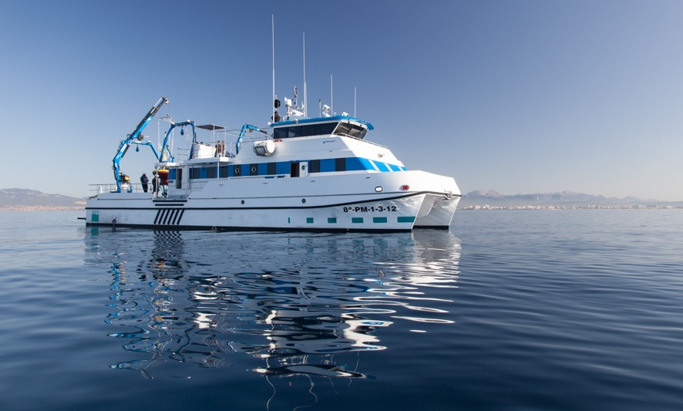

**1. Competitive Users Access Guidelines**

R/V SOCIB has been operational since 2013. A detailed description, including technical characteristics, equipment, crew, berths, endurance, etc. can be found at [SOCIB Cat web site](http://repository.socib.es/repository/entry/get/Top/Public%20Staff/tcanyellas/Diptic_catamaran_web.pdf?entryid=a862756d-faba-492e-a5f2-50b3fe512291). SOCIB R/V is operated by IEO and included in its oceanographic research fleet, in line with the agreement signed in 2013 by SOCIB, IEO and CSIC. SOCIB R/V is a member of the European Research Vessels Operators ([ERVO](http://www.rvinfobase.eurocean.org)) since 2013.

As detailed in theses guidelines, external scientific users can apply on a peer review competitive basis for ship time on-board R/V SOCIB. Daily costs as approved in December 2013 are detailed in Annex B.2.1.

The procedure for competitive access to SOCIB R/V ship time is the same as for all R/V that are managed by the Spanish Commission responsible for coordination of R/V activities (COCSABO, *Comisión de Coordinación y Seguimiento de las Actividades de los Buques Oceanográficos*) where she has been included since 2013.

COCSABO coordinates all the scientific and technical activities carried out by the Spanish oceanographic research vessels (those belonging to IEO and CSIC, and also the BIO *Hesperides*), including the scheduling and calendar of each vessel.

In order to apply for competitive ship time on-board R/V SOCIB the formal procedure includes an application form (Annex B 2.2) that is evaluated by the COCSABO. More detailed information, including prices, forms and availability can be found at [COCSABO website](http://www.idi.mineco.gob.es/portal/site/MICINN/menuitem.8ce192e94ba842bea3bc811001432ea0/?vgnextoid=9ae9f0865a455210VgnVCM1000001d04140aRCRD&vgnextchannel=39ecedd435c25210VgnVCM1000001d04140aRCRD).

As explained in this site[7], to apply for an oceanographic campaign from the Spanish research fleet, an application has to be filled usually through projects of the Spanish National R+D Plan. Once a Project is approved, the National Plan sends to the COCSABO a list of the projects to be financed that include ship time for a certain R/V. COCSABO creates a final annual schedule for each of one the R/Vs. This information is circulated through the National Plan for Research and accordingly external users that have applied through the National Plan will be informed.

In line with the indications provided in the same site, Universities, public research institutions, and/or commercial organizations can apply for direct non-competitive access to the R/V SOCIB, then contacting directly the Office of the Director of SOCIB.

**2. Annexes B**

## B. 2.1: SOCIB R/V daily costs for academic and private organisations





**Tarifas de empleo del catamarán SOCIB**

**fijadas en la 1ª Reunión de la Comisión de Seguimiento en el marco del Convenio SOCIB-CSIC-IEO**

Estas tarifas se han establecido en línea con los criterios de estimación de costes de operación de los buques oceanográficos que establece el IEO para sus buques oceanográficos (según resolución anual del Director del IEO) y de acuerdo a los criterios que, a nivel nacional, se discutieron en las reuniones del GT Costes de la COCSABO. Así mismo estos criterios son coincidentes, a nivel internacional con los que se aplican en diferentes países europeos tras su análisis en el marco de la “European Research Vessels Operators Group” (ERVO).

Estas tarifas cubren exclusivamente los costes de explotación del buque por lo que en ningún caso existe un beneficio en la operación del mismo.

**Tarifa** de aplicación en **proyectos de investigación competitiva[8]** o en el marco de la actividad de los miembros firmantes del Convenio:

* **Salidas de 24 horas con 9 tripulantes**
  + **4.500 €/día**
* **Salidas de 8 horas con 3 tripulantes**
  + **2.200 €/día**
* Comprende un régimen de **velocidad nunca superior a 12 nudos**.
* En campañas de 24 horas se incluirá un día adicional de movilización/desmovilización en puerto
* En salidas de 24 horas incluye la manutención.
* Precios IVA no incluido.

En principio los tránsitos para el desarrollo de campañas podrán tener coste que podrá ser del 50 al 100 % de los días de duración del mismo.

## B. 2.2: SOCIB R/V proposal for ship time template.

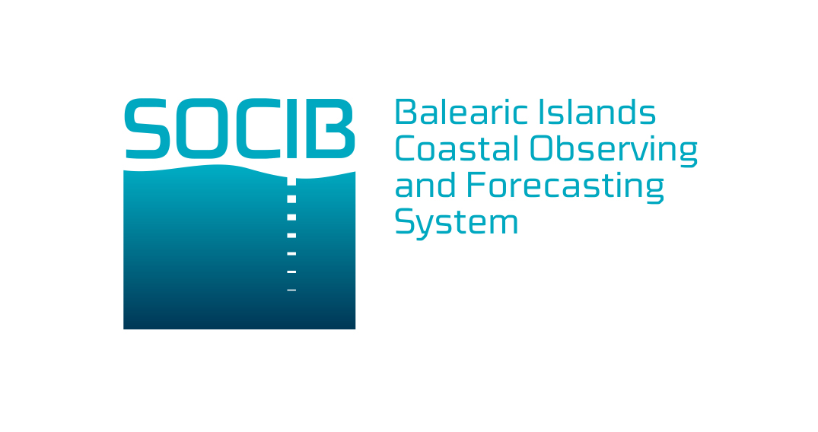

***SOLICITUD TIEMPO BUQUE SOCIB***

Los buques oceanográficos constituyen la herramienta fundamental en la investigación de los océanos y sus recursos y cuentan con un complejo y sofisticado equipamiento. El buque oceanográfico SOCIB es un catamarán costero de investigación con base en Palma de Mallorca propiedad de la ICTS SOCIB.

El Convenio específico de colaboración firmado entre la ICTS SOCIB, el IEO y el CSIC a 1 de enero de 2013 establece las bases para la operación ordinaria del catamarán por parte del IEO, incorporándose el mismo a la flota de buques del IEO. En el mismo se acuerda que el IEO asume la gestión técnica integral y la operación del catamarán, actuando como Armador del buque, así como la colaboración del CSIC en la gestión, operación y mantenimiento de los equipamientos científicos adscritos al catamarán. De esta forma, se rentabilizan y optimizan, tanto la inversión del SOCIB, como la experiencia del IEO y CSIC en la gestión integral de buques oceanográficos y sus equipamientos

El IEO ha incorporado el catamarán SOCIB a su flota de buques oceanográficos y gestiona el calendario de campañas de acuerdo a sus compromisos y necesidades de uso y en línea con los principios de acción de la COCSABO. Al mismo tiempo, el catamarán SOCIB se encuentra integrado entre los buques de la COCSABO, que gestiona el tiempo buques oceanográficos prestando por tanto servicio a las campañas que se desarrollan en el marco del *Plan Nacional de I+D+i*, así como las del programa marco de la Unión Europea y las propias responsabilidades de asesoramiento asignadas a los diferentes OPIs del MINECO, como el *Programa Nacional de Datos Básicos* cofinanciado por la UE. Además existen otras campañas que eventualmente pueden desarrollarse en estos buques en virtud de iniciativas auspiciadas desde otros estamentos del Estado, incluyendo las del Ministerio de Asuntos Exteriores en el programa de Extensión de Límites, iniciativas relacionadas con el *Proyecto LIFE* del Ministerio de Agricultura y Medio Ambiente, de la AECID o también de las Comunidades Autónomas.

En este sentido, se ha diseñado esta ficha de “**Solicitud de Tiempo del Buque SOCIB**” para todas aquellas campañas que no se desarrollan en el marco de Plan Nacional de I+D+i con el objetivo de conseguir una mejor planificación y coordinación de la utilización de los buques asignados a la COCSABO. Esta ficha permitirá conocer las iniciativas que se están preparando y permitirá la elaboración de los borradores de calendarios de los buques.

El formulario de **Solicitud de Tiempo del Buque SOCIB** debe ser remitido a la Secretaría del Departamento de Gestión Naval, Campañas y Equipamiento del IEO [SolicitudTiempoBuqueIEO@st.ieo.es] con al menos **18 meses de antelación** (pero nunca menos de 12 meses) a la época en que se vaya a desarrollar la campaña.

Este formulario de **Solicitud de Tiempo del Buque SOCIB** es el documento fundamental a la hora de preparar el borrador de calendario para la operación de este buque, en el marco de la flota del IEO.

**INFORMACIÓN PRELIMINAR SOBRE LA CAMPAÑA**

Acrónimo

1. Investigador principal

Datos de contacto incluyendo la

Institución a la que pertenece

(email y teléfono)

2. Nombre del proyecto

Código de referencia en su caso

3. Jefe de Campaña

Si es distinto del Investigador

Principal (email y teléfono)

4. Descripción del proyecto o campaña

(nvuuuu

5. Centros involucrados en la campaña/proyecto

6. Marco de referencia campaña

Financiador: PNDB, UE, Plan Nacional, CCAA

**INFORMACIÓN LOGÍSTICA**

7. Buque (el nombre del buque será siempre orientativo)

8. Área de trabajo

(Incluir croquis o mapa)

Precisar

9. Días de trabajo (días completos de tiempo **10. Número de Plazas**

de buque necesarios para la campaña, sin tránsitos)

11. Fechas previsibles de campaña

(Época **preferida** del año)

12. Equipamiento a bordo necesario

13. Equipamiento portable del buque necesario

14. Equipamiento propio aportado por el personal implicado

15. Comentarios (Indicar si se puede agrupar con otras campañas simultáneamente)

**Nota Adicional.- El solicitante** de **tiempo de buque SOCIB**, **se obliga y compromete a**:

 Colaborar con el DGNCE y otros departamentos del SOCIB, del IEO y del CSIC en la preparación de la campaña

 Hacer constar el apoyo de SOCIB/IEO/CSIC en los resultados del proyecto o informe (publicaciones etc.) y en cualesquiera acciones de difusión y divulgación relacionadas con el mismo.

 Entregar al IEO y a SOCIB, inmediatamente tras la realización de la campaña, un **informe de campaña** remitido al Coordinador de Equipamiento Científico jose.diaz@st.ieo.es así como un listado con los **metadatos** obtenidos en ella al Centro de Datos **CEDO** del IEO y del SOCIB .

 Todos los informes, posters, publicaciones, libros, etc., en los que se hayan obtenido datos del buque SOCIB o hayan empleado alguno de los CTD, MOCNESS, así como en su caso el logo que se encuentra a continuación:

**Equipamiento *B/O SOCIB*: FICTS-2010-01**

***B/O SOCIB:*  FICTS-2011-03-01**



1. Although it was partially included in Section 2.6.2 Access: pp.154-156, and Annexes A3: p.241, A4: p.243, A5: p.245
2. As described in 2nd parag. from the Executive Summary, p. 6.
3. [Expert Group on Marine Research Infrastructures; 2013: “Towards European Integrated Ocean Observation](http://ec.europa.eu/research/infrastructures/pdf/toward-european-intagrated-ocean-observation-b5_allbrochure_web.pdf). doi 10.2777/29343. ISBN 978-92-79-27319-3.
4. See 2102 update: <http://europa.eu/rapid/press-release_MEMO-12-772_en.htm?locale=en>
5. JERICO: Towards a Joint European Research Infrastructure network for Coastal Observatories
6. Tentative title: Supporting flagship international cooperation initiatives: Mediterranean and Black Sea Cooperation Research Alliance
7. COCSABO: [Procedimiento del Grupo de Trabajo de Calendarios, Julio 2](http://www.idi.mineco.gob.es/stfls/MICINN/Ayudas/PN_2008_2011/LIA_Infraestructuras_Cient%C3%ADficas_Tecnol%C3%B3gicas/FICHERO/icts_anterioresplan/Procedimiento_GTCalendarios.pdf)005
8. Esta tarifa se entiende para usuarios de los centros públicos de I+D+i en el marco de proyectos de investigación o convenios con instituciones públicas. En el caso de **otros usuarios**, en línea con la resolución anual del Director del IEO, la **tarifa** se **incrementará en un 20%**.